[KTM](http://www.ktm.com/ca-en/)

**Beagle Bash Trail Ride Part of the OFTR Series  
Sunday April 30/2017 LVDR**

**Start:** Pavilion behind arena, 30 Albert St. Langton, Ontario

After ride barbeque available

**Entry:** Post entry only: $40.00

**Times:** Start Time: 10:00 am Sign-in Sunday 7:30 to 9:30. Rider’s meeting at 9:45

Go to sound test before registering.

Fuel available will be at a gas station.

**Course:** Course is mainly single track. Difficulty level is 3-4 out of 5.

Soil is sandy to sandy loam. Difficult sections will have by-passes.

**Motorcycle:**

All motorcycles must be Ontario road legal. (Blue Plated)

Working headlight, tail light, horn and mirror.

Proper tires

Bikes must be quiet. Maximum sound level of 94db as per test

procedure.

Spark arrestor required.

Bikes will be inspected before sign-in.

**Information:** Marc 519-472-0061 [marcg123@bell.net](mailto:marcg123@bell.net) For more info go to[**www.offroadontario.ca**](http://www.offroadontario.ca)

Click forum, see trail rides

 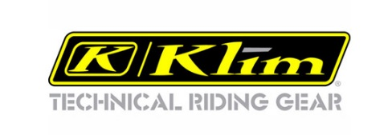 

http://oftr.ca/photos/custom/Lang_Offroad_SHERCO_banner_Reduce.jpg 

  [](http://www.getnano.ca/gallery)