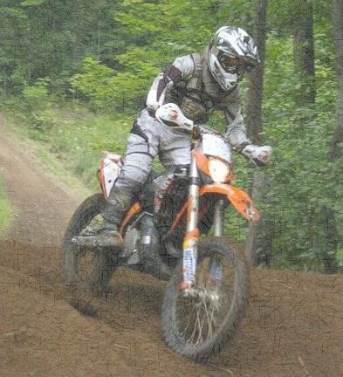**COLIN SNIDER MEMORIAL**

**OCTOBER 26 2014**

**TEAM EVENT**

**GET YOUR TEAM TOGETHER**

**AND ENTER IN OUR**

**2-MAN, 3-4 MAN CLASS,**

**OR**

**ENTER IN OUR IRONMAN CLASS**

**THIS COULD BE THE LAST RACE BEFORE THE**

**SNOW FLIES.**

**REGISTRATION STARTS @ 9:00 am**

**RACE STARTS @ 12:00 pm**

**BBQ ON SITE**

**PROCEEDS FROM THIS EVENT GO TO LOCAL CHARITIES**